**Question Bank template**

|  |  |  |  |
| --- | --- | --- | --- |
| **Q. No** | **Statement** | **Unit** | **Mark** |
| 1 | Define Cascading Style sheets | Unit-II | 2 |
| 2 | Define CSSrule | Unit-II | 2 |
| 3 | List the two variations of CSS | Unit-II | 2 |
| 4 | Enumerate CSS framework | Unit-II | 2 |
| 5 | Enumerate the limitations of CSS | Unit-II | 2 |
| 6 | Define the CSS filters | Unit-II | 2 |
| 7 | Write the code to set property for controlling image repetition of background | Unit-II | 2 |
| 8 | Define CSS rules overriding | Unit-II | 2 |
| 9 | List the advantages of CSS rules overriding | Unit-II | 2 |
| 10 | List the steps to integrate CSS on web page | Unit-II | 2 |
| 11 | Enumerate CSS Style Components | Unit-II | 2 |
| 12 | Demonstrate the use of CSS Opacity with example. | Unit-II | 2 |
| 13 | Discuss advantages of embedded style sheets | Unit-II | 2 |
| 14 | Determine the steps to restore the default value using CSS | Unit-II | 2 |
| 15 | Write a CSS code for table cell padding. | Unit-II | 2 |
| 16 | Enumerate the float property attributes of CSS | Unit-II | 2 |
| 17 | Write a CSS code to get input using padded input text field. | Unit-II | 2 |
| 18 | Write a multi line comment using CSS. | Unit-II | 2 |
| 19 | Write a CSS code to set a background color an element. | Unit-II | 2 |
| 20 | Write a property name is used to set opacity of an image. | Unit-II | 2 |
| 21 | Which property is used to set the width of an image border? | Unit-II | 2 |
| 22 | Identify two differences between CSS2 and CSS3. | Unit-II | 2 |
| 24 | Identify the CSS text property to set the text direction in a web page. | Unit-II | 2 |
| 25 | Design the CSS code to set the opacity property of an image. | Unit-II | 2 |
| 26 | Create the CSS code to get a padded input text in the web form. | Unit-II | 2 |
| 27 | Create the css code to set background color of web page. | Unit-II | 2 |
| 28 | Design the css code to increase white space between words in a web page. | Unit-II | 2 |
| 29 | Design the css code to add different color to unvisited hyperlinks. | Unit-II | 2 |
| 1 | Discuss advantages of External Style Sheets | Unit-II | 5 |
| 2 | Explain  CSS Box Model with an example | Unit-II | 5 |
| 3 | Compare and differentiate Logical and Physical tags | Unit-II | 5 |
| 6 | Explain CSS Multicolumn properties. | Unit-II | 5 |
| 7 | Differentiate id selector and class selector | Unit-II | 5 |
| 1 | Discuss the methodology to make external style sheets | Unit-II | 10 |
| 2 | Illustrate CSS rules overriding with an example | Unit-II | 10 |
| 4 | Analyze the pros and cons  of CSS with HTML | Unit-II | 10 |

**Section B – 5 Marks**

**4.**

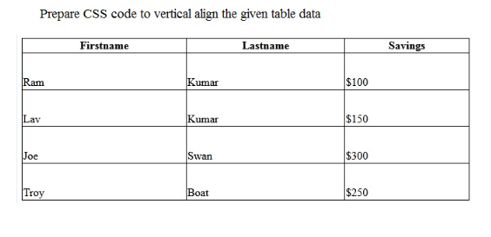

**5.**

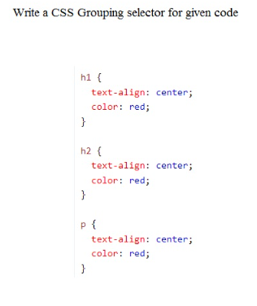

**8,**

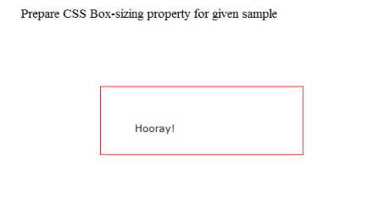

**9,**

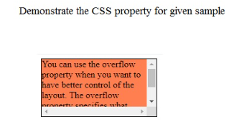

**10,**

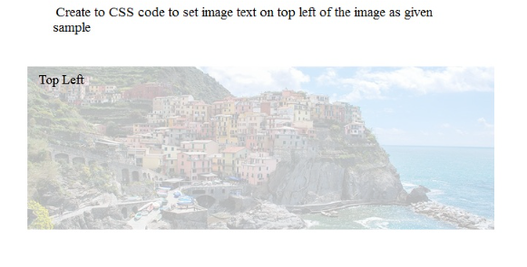

**11**

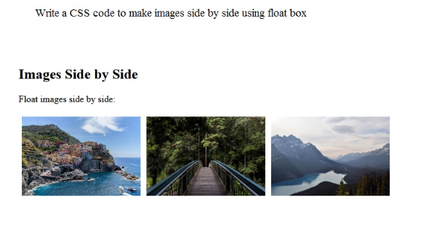

**12**

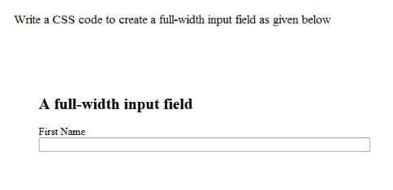

**13**



**14**

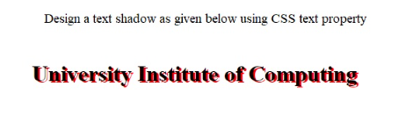

**SECTION C- 10 marks**

**3,**

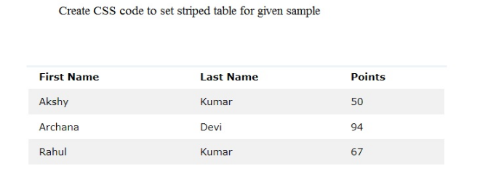

**5,**

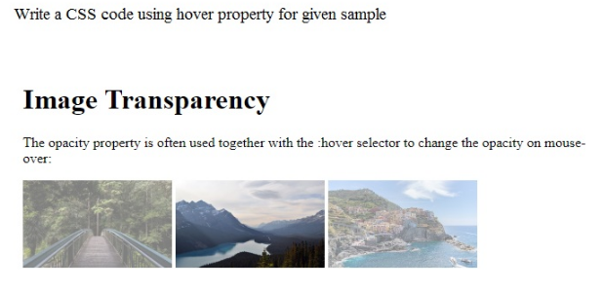

**6**

